Submission to the Retirement Living Code of Conduct
Background
The Old Colonists’ Association of Victoria (OCAV) is a leading not-for-profit retirement village provider offering a continuum of care from independent living, assisted living and aged care in Victoria. Our four villages in Berwick, Euroa, North Fitzroy and St Helena are home to 500 older Victorians in need.
OCAV was established almost 150 years ago by a group of prominent Melburnians to ensure that older Victorians in need had somewhere secure and affordable to live, support when and if they needed it, and a community in which they felt engaged.
Our mission remains unchanged. The need is greater than ever with an increase in single homeless women, a lack of affordable rental housing, limited public housing.
As a leading retirement village and aged care provider in Victoria, we work to provide affordable and safe housing for elderly Victorians in need, whether they live independently, or in supported or aged care living. Many of our residents have lived within OCAV villages for ten years and longer, maintaining relationships with friends and families.
Our funding model:
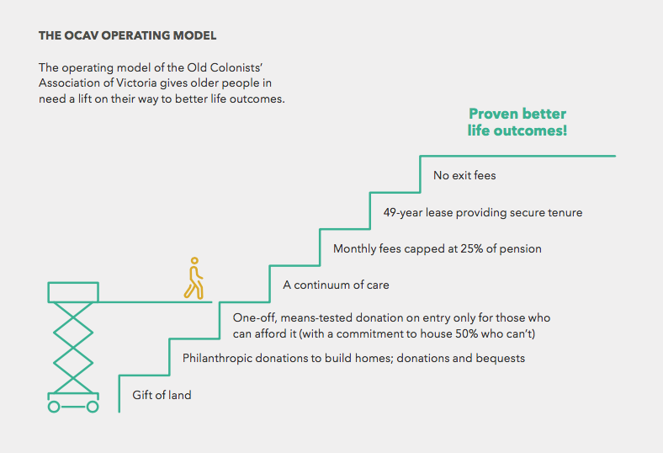
Our comments in general:

We question whether a voluntary Code is ultimately enforceable. The track record of some operators would suggest not.

The Code as it currently stands does not spell out the implications of non-compliance. This is an oversight and needs to be addressed.

However, there are several good reminders in this Code about the importance of training and communication with residents.

Specific comments

B1.3: We need to be mindful of privacy issues when it comes to sharing information about current residents.

B1.5: “Sufficient”: we recommend a clear timeframe. Sufficient is too loose a word.

B2.5: “If appropriate”: when won’t it be appropriate? This needs to be spelled out more clearly.

B2.8: This clause has to be made in accordance with the Act. We should be wary of making any statement about this, however good the intention of the clause.

C2.1: This clause delves into areas which are not appropriate for a Code of Conduct.

D1.1 “Endeavour: this does not mean that operators will be clear. The language needs to be strengthened.

Cost to code signatories: What are the costs involved; include a table in the final Code. Also, how can an operator ensure access to the CAC when and if required.

